**The Ecological Structure of Mosquito Population Dynamics: Insights from India, Consequences for Malaria Control**

Charles Whittaker1*, Peter Winskill1, Marianne Sinka2, Samuel Pironon3, Claire Massey4, Ashwani Kumar5, Azra Ghani1+ & Samir Bhatt1,6+

1Department of Infectious Disease Epidemiology, Imperial College, London, UK

2Department of Zoology, University of Oxford, Oxford, UK

3Insert Samuel’s affiliation here

4Big Data Institute, Li Ka Shing Centre for Health Information and Discovery, University of Oxford, Old Road Campus, Oxford, UK.

5Insert Ashwani’s affiliation here

6Malaria Atlas Project, Oxford Big Data Institute, Nuffield Department of Medicine, University of Oxford, Oxford, UK

*Corresponding Author: [charles.whittaker16@imperial.ac.uk](mailto:charles.whittaker16@imperial.ac.uk)

+ Denotes joint-authorship

**Significance**

Understanding the temporal profile of malaria risk, which is a product of underlying mosquito population dynamics, is essential to effective planning and control of the disease. Here, we collate a database of monthly mosquito catch data spanning 40 years and 117 locations across the Indian subcontinent in order to better resolve the complex ecological interplay between mosquitoes and their wider environment that shapes these temporal dynamics. Our analyses highlight extensive diversity in mosquito population dynamics, both within (across different locations) and between (in the same location) species, as well as discrete ecological structuring of the timing and extent of seasonality. Importantly, we demonstrate that the temporal profile of malaria risk can be clustered into a small number of policy relevant temporal patterns and provide a predictive tool to inform the planning and timing of control efforts.

**Abstract**

Understanding the temporal dynamics (including the start, duration and end) of malaria transmission in a given location represents a vital input to optimising control strategies aimed at reducing malaria transmission, enabling interventions to be deployed at times and in places where they can have the most impact. Despite this, many outstanding questions remain surrounding the drivers of these dynamics, particularly surrounding their dependence on the underlying ecological structure of a setting. Here we collate temporally disaggregated mosquito catch data from across the Indian subcontinent in order to better understand these dynamics and the factors shaping them. Statistical analysis and characterisation of these time series reveal marked diversity in temporal dynamics including extensive plasticity in dynamics populations of the same species across different settings. We show that this variation is underpinned by a complex interplay between mosquito species and abiotic ecology, but that can be clustered into a small number of temporal modalities. Analyses of these distinct clusters using a multinomial logistic regression-based approach, we show that the observed plasticity intimately depends on the particular ecology of a setting, which interacts with intrinsic species-related factors to shape and define the temporal dynamics (including timing and extent of seasonality) of mosquito populations. The results of these analyses are then integrated with spatial predictions of species presence/absence in order to generate predictive maps of mosquito population seasonality across India, to inform the planning and timing of control efforts.

**Background**

Responsible for an estimated 216 million cases and 454,000 deaths in 2016 alone1, malaria represents one of the most serious infectious diseases globally2. Transmission of the *Plasmodium* parasite responsible for causing the disease occurs through mosquitoes belonging to the *Anopheles* genus. Of the 460 recognised *Anopheline* species, approximately 70 possess the capacity to transmit human malaria parasites3,4. These vectors are heterogeneously distributed across the globe, a feature that results in marked differences in the transmission dynamics and epidemiology of malaria across different contexts and ecologies.

A substantial body of work has focussed on the spatial distribution (presence/absence) of these vectors including mapping their current distribution across different global regions5,6 as well as the trajectories and dynamics of these distributions over time in response to climate change and other factors7. This work has involved relating vector occurrence to a variety of different environmental variables and has proved highly useful in enabling strategically targeted surveillance and control programmes aimed at mitigating the impacts of vector borne diseases worldwide.

By contrast, less attention has been paid to understanding the temporal patterns of vector abundance, and how these are dynamics are shaped by the local environment. Mosquito populations are highly dynamic over time, exhibiting substantial fluctuations in size over the course of a year, a feature which in turn leads a similarly dynamic and temporally variable profile of malaria risk. Rainfall is frequently considered a key determinant of these dynamics due to the requirement of the early life cycle stages of the mosquito for an aquatic habitat in which to develop and the preference many species display for transient, rain fed pools of water in which to breed8.

However, whilst a close relationship between the occurrence of rainfall and peaks in malaria infection in many locations has been observed9, these relationships have frequently been far from clear-cut. Whilst the population dynamics of *Anopheles gambiae* were shown to be highly concordant with rainfall during entomological investigations in the Garki District of Nigeria10, *Anopheles funestus* populations by contrast frequently display a lack of marked seasonal fluctuations in population abundance. This feature has previously been attributed to its preference for large permanent/semi-permanent bodies of fresh water as breeding habitats11 (suggesting that these dynamics can operate independently of rainfall) and is thought to be a substantial contributor to the perennial malaria transmission observed across parts of Eastern Africa12,13. Further complicating matters, not all variation in population dynamics appears to be species-specific. Indeed, there exist numerous instances of variation in the seasonal dynamics displayed by the same species found across different locations e.g. as observed for *Anophleles annularis*, whose dynamics can range from near-perennial through to intensely seasonal14. The exact role of rainfall (which can either generate new breeding sites or destroy them based on the level of rainfall15–17), how it interacts with the ecological structure of the local hydrological environment environment (which determines the comparative composition of permanent and temporary aquatic habitats available and their physio-chemical characteristics18), and how these factors interact with species specific breeding site preferences to shape mosquito population dynamics therefore remains unclear.

Additionally, rainfall is not the only factor likely contributing to the observed diversity in mosquito population dynamics. Indeed, it is likely that a wide array of ecological factors contribute to the observed variation, although the identity of these factors and the extent of their influence remains poorly resolved. For example, whilst extensive work has been published highlighting the influence of temperature on many mosquito traits (such as larval development19, biting rates and mortality rates20), many of these have focussed on constant temperatures under controlled laboratory conditions, rather than field settings where temperature can fluctuate substantially over a variety of different timescales.

A number of outstanding questions remain then, surrounding the influence of rainfall on mosquito population dynamics, the role of other environmental factors, and how these factors interact with species-specific preferences to shape and structure mosquito population dynamics. Understanding these drivers is crucial given that some of the most effective malaria control interventions are critically dependent on accurate timing of delivery in relation to seasonal peaks in disease risk such as Seasonal Malaria Chemoprevention (involving, involving monthly administration of long-acting antimalarials to children under 521 before and during the seasonal peak in transmission) and Indoor Residual Spraying22 (spraying houses with insecticides to kill mosquitoes). Efficacy of these interventions is intimately dependent on timing relative to the seasonal peak of transmission23,24 and so a better understanding of the factors underlying both the timing and extent of seasonal fluctuation in mosquito populations (and by extension, malaria risk) would therefore enable more accurate and effective deployment of these highly efficacious interventions.

Here we collate temporally disaggregated mosquito catch data from across the Indian subcontinent in order to better understand the extent and drivers of variation in mosquito population dynamics. India is well positioned to in this respect due to the high diversity of malaria-competent vectors it is home to25, as well as its history of publishing high quality, temporally resolved and comprehensive entomological data. Using this data, we employ an array of statistical methods to characterise the observed temporal patterns and uncover structural similarities in the dynamics across populations and locations. Our results reveal pronounced heterogeneity in the extent, nature and dynamics of seasonal fluctuations across different mosquito populations. They underscore the critical interaction between abiotic and biotic factors in determining the population dynamics of these important disease vectors and the importance of considering ecological structure when designing malaria intervention strategies.

**Methods**

**Systematic Review of Indian Entomological Literature**

Web of Science and PubMed databases were searched on 17th October 2017 using the keywords “India” AND “Anophel*” in order to identify references containing temporally disaggregated entomological data. Our searches identified a total of 1945 records, with 1556 remaining after duplicate removal. Following Title and Abstract screening, a total of 281 records were retained for full text evaluation. Records that contained temporally disaggregated mosquito catch data spanning at least 12 months at a monthly (or better) temporal resolution and that had not been conducted in settings where an active trial of vector control interventions was ongoing were included. Those not satisfying these criteria were excluded, as well as both records where geolocation was not possible due to a lack of spatial information and records which contained information on the immature/larval mosquito life cycle stages only. Using these criteria, a total of 78 references were retained following Full Text Evaluation, yielding 117 distinct geolocatable areas across the Indian subcontinent. Together, these references contained a total of 272 time series spanning the known malaria vectors *Anopheles annularis*, *Anopheles culicifacies*, *Anopheles dirus*, *Anopheles fluviatlis*, *Anopheles minimus*, *Anopheles stephensi* and *Anopheles subpictus*. See Supplementary Information “Data Extraction, Collation and Initial Processing for further details.

**Time Series Fitting and Interpolation**

In order to facilitate spatial interpolation between the monthly catches, and to smooth the inherent noise in the collated mosquito catch data (without distorting the legitimate temporal patterns present), we fitted a highly flexible class of stochastic models known as Gaussian Processes to each of the extracted time series. Whilst these are typically fitted using a Gaussian likelihood, the time collated time series were fitted using a Negative Binomial likelihood in order to account for the overdispersion typically present in mosquito catch data. This inferential framework was formulated as follows:

where is a vector of values representing a realisation from Gaussian Process, our observed counts, indexed by timepoint using the index and represents a vector of hyperparameters involved in defining the functional form of the covariance function. Given mosquito population dynamics are typically characterised by repeating patterns occurring either seasonally or annually, a periodic function was used to define the covariance between pairs of points, with the following specification:

where represents the period over which we would expect points to show similar dynamics (i.e. a period of twelve would imply we expect points separated by 12 months to be most similar etc), specifies the magnitude of the covariance, and represents a lengthscale parameter further constraining the extent to which two values separated by a given distance (in time in our case) can co-vary with one another. Weakly informative priors were used, and the Negative Binomial Gaussian Process fitted to each of the extracted time series using the probabilistic programming language STAN26. For more details see Supplementary Information “Negative Binomial Gaussian Process – Fitting and Inference”.

**Time Series Characterisation and Clustering by Features**

We applied a series of mathematical operations to the fitted time series in order characterise their temporal properties. These include the Kullback-Liebler divergence (measuring the divergence of the time series from a uniform distribution), the median of the period () from the Negative Binomial Gaussian Process fitting (informing the dominant temporal modality present in the data), the proportion of points greater than 1.65x the mean (measuring how peaked the time series is), the distance of the first peak from January, and then 3 features arising from fitting 1 and 2 component Von Mises distributions to the fitted time series, specifically the mean of the 1 component fitted Von Mises distribution, the number of peaks (determined by comparing the quality of fit for 1 and 2 component Von Mises distributions), and the weight (), specifying the comparative contributions of each component in the two-component fitting. See Supplementary Information “Time Series Characterisation and Analysis” for further details. The result of this characterisation is a series of 7 values (representing the output of each our 7 mathematical operations) describing the temporal properties of each time series. To this data, we then applied a Principal Components analysis of these results in order to identify a low-dimensional representation of the structure present in the data amenable to visualisation, and implemented the k-means clustering algorithm in order to identify groups of time series with similar temporal features.

**Statistical Modelling and Prediction of Seasonal Modality**

For each of the 117 study locations, we extracted a suite of environmental variables derived from satellite data that together describe the ecological structure of the location. These include the BioClimatic variables (a suite of biological relevant covariates defined from monthly ranfall and temperature satellite data27), various measures of aridity, a number of covariates describing the seasonality and extent of water bodies, the enhanced vegetation index (EVI), landcover and a number of other related variables previously used in projects mapping the distribution of *Anopheline* vectors25. For further information and a complete list of the covariates used, see Supplementary Table 2. Together with the *Anopheline* mosquito species each time series belonged to, these variables were used as covariates in a penalised (L2) multinomial logistic regression framework to predict the cluster of temporal patterns a particular time series belongs to. The results of these analyses were then integrated with recently produced maps of vector presence/absence to generate predictive maps of mosquito population dynamics across the Indian subcontinent (see Supplementary Information “Penalised Multinomial Logistic Regression Modelling, Evaluation of Model Accuracy and Predictive Modelling” for further detail).

**Results**

**Substantial Diversity in Mosquito Population Dynamics Both Within and Between Species:** A total of 108 references, containing 272 time series from 117 locations across India were identified through the systematic review **(Fig.1A)**, which were then fitted within a Negative Binomial Gaussian Process based framework. The results of this fitting reveal pronounced heterogeneity between different species in their temporal dynamics over the course of a year **(Fig.1B)**. Whereas *Anopheles dirus* populations tended to peak during the monsoon period (typically June to September), by contrast, in many instances, *Anopheles fluviatilis* populations peaked around November to February (the dry season across most of India), and reached their lowest point during the monsoon. A number of *Anopheles subpictus* time series showed distinct evidence of bimodality, with peaks occurring both in the months of March – May and then during the August – September period, whilst a number of *Anopheles annularis* populations demonstrated perennial patterns of abundance. We also observed extensive variation in temporal dynamics within species. Across the 85 time series collated for *Anopheles culicifacies*,populations varied significantly in both the extent and timing of their seasonal peaks: whereas some displayed sharp peaks in the monsoon season, others displayed perennial characteristics similar to those observed for *Anopheles annularis*. Similar patterns were observed across the raw, unfitted time series (**Supplementary Figure 1**).

**Characterisation and Clustering of Mosquito Catch Time Series Properties Reveals Discrete Temporal Modalities:** Having identified substantial variation in the temporal dynamics of mosquito populations, we next asked whether this variation could be delineated into distinct clusters based on the characteristics of the time series. Statistical characterisation of their temporal properties followed by k-means clustering **(Fig.2A)** demonstrated the existence of 4 clusters with distinct temporal properties (**Supplementary Figure 2)**. Specifically, it identified time series peaking during the monsoon season **(Fig.2B Cluster 1)**, displaying bimodal characteristics **(Fig.2B Cluster 2)**, peaking in the dry season **(Fig.2B Cluster 3)** or displaying limited seasonal variation and perennial-like behaviour **(Fig.2B Cluster 4).** These results were not sensitive to the choice of Prior used in the fitting process **(Supplementary Figure 3)**. Importantly these dynamics appear to occur despite similar rainfall patterns and timings across all of the locations we examined**.** The cross-correlation product between rainfall and mosquito densities was highly positive for Cluster 1, negative for Cluster 3 and near 0 for Clusters 2 and 4 **(Supplementary Figure 4)**. This indicates that the observed patterns in mosquito population dynamics are not due to differences in the timing and extent of rainfall across India – instead, it represents genuine differences between mosquito species and locations with the way in which they react and respond to incipient rainfall. Analysing the proportion of a given mosquito species’ time series belonging to a particular cluster (**Supplementary Figure 5)** revealed that, for a number of species such as *Anopheles dirus* and *Anopheles fluviatilis*, the majority of the time series belonged to a single cluster (Cluster 1, peaking during the monsoon season, and Cluster 3, peaking during the dry season, respectively), indicating strong species-specific tendencies for these particular temporal dynamics. By contrast, other species showed extensive plasticity in the temporal patterns observed, with *Anopheles culicifacies* and *Anopheles stephensi* time series being near-uniformally distributed across the temporal clusters (indicating the capacity to adopt a wide and diverse array of temporal dynamics, depending on the particular location and ecological setting).

**Mosquito Population Dynamics are Determined By A Complex Interplay of Abiotic and Biotic Factors:** In order to assess the drives of these different temporal patterns, and using both species and a suite of ecological covariates as variables, we fitted a multinomial logistic regression to the cluster labels (denoting which cluster each time series belongs to), to explore the drivers and determinants of these different temporal patterns. Overall, the model was able to assign time series into the correct cluster 60% of the time (compared to the 25% expected for a completely random classifier), indicating modest but significant predictive performance. We next assessed the size and direct of the regression coefficients – the multinomial logistic framework used here produces estimates of 1 coefficient for each cluster, with that coefficient defining the strength of the association linking each covariate to a particular cluster (and by extension, temporal pattern). These results revealed distinct species-specific tendencies for particular clusters. Indeed, hierarchical clustering of the species coefficient values for each cluster identified significant structuring **(Fig.3A)** – *Anopheles culicifacies* and *Anopheles subpictus* clustered together, indicating that these species displayed similar associations with each temporal cluster (in particular a strong positive association for Cluster 1, the monsoon peak, a strong negative association for Cluster 3, the dry season peak and only weak associations with Clusters 2 and 4). *Anopheles fluviatilis* by contrast displayed the opposite pattern. *Anopheles minimus*, *Anopheles dirus* and *Anopheles stephensi* all displayed similar associations to one another, which were small, suggesting the absence of a strong species-specific tendency to adopt a particular temporal pattern (and indicating a role for ecological structure as the primary determinant of their dynamics). Analysis of the coefficients for the ecological covariates highlighted distinct ecological structuring of the drivers of each cluster’s temporal pattern –each cluster’s ecological coefficients were ranked according to the strength of its association (either positive or negative) with that cluster, and the top 20 coefficients selected. The extent of overlap in these top 20 coefficients between clusters was then assessed, revealing minimal overlap between clusters **(Fig.3B)** and suggesting that the different temporal patterns characterising each cluster are a product of distinct ecological forces **(Supplementary Figure 7 and Supplementary Figure 8)**.

**Predictive Mapping Highlights the Extensive Variation in Seasonal Mosquito Dynamics and Malaria Risk Across India.** We next integrated the results of this multinomial modelling with recently generated spatial predictions of mosquito species presence/absence to produce predictive spatial maps of mosquito population dynamics across the Indian subcontinent. Specifically, we used this framework to generate estimates of the probability that a given location contains at least one mosquito species displaying each of the four different temporal modalities identified through the clustering approach **(Fig.4)**. Our results predict that monsoon concordant dynamics (corresponding to Cluster 1) are most likely in the North and Northeast **(Fig.4A)**. This is in contrast to the predicted spatial distribution of bimodal dynamics (Cluster 2), which are predicted to be most likely all of central India and less likely in the Northeast. Dynamics involving peaks during the dry season tracks the predicted spatial distribution of *Anopheles fluviatilis* closely and is predicted to be most probable across central India **(Fig**.**4C)** – a similar pattern was observed for spatial predictions of perennial dynamics (Cluster 4, **Fig.4D)**. Together these results suggest that spatial variability in both species occurrence and environmental factors together generate complex patterns of mosquito temporal dynamics across the Indian subcontinent.

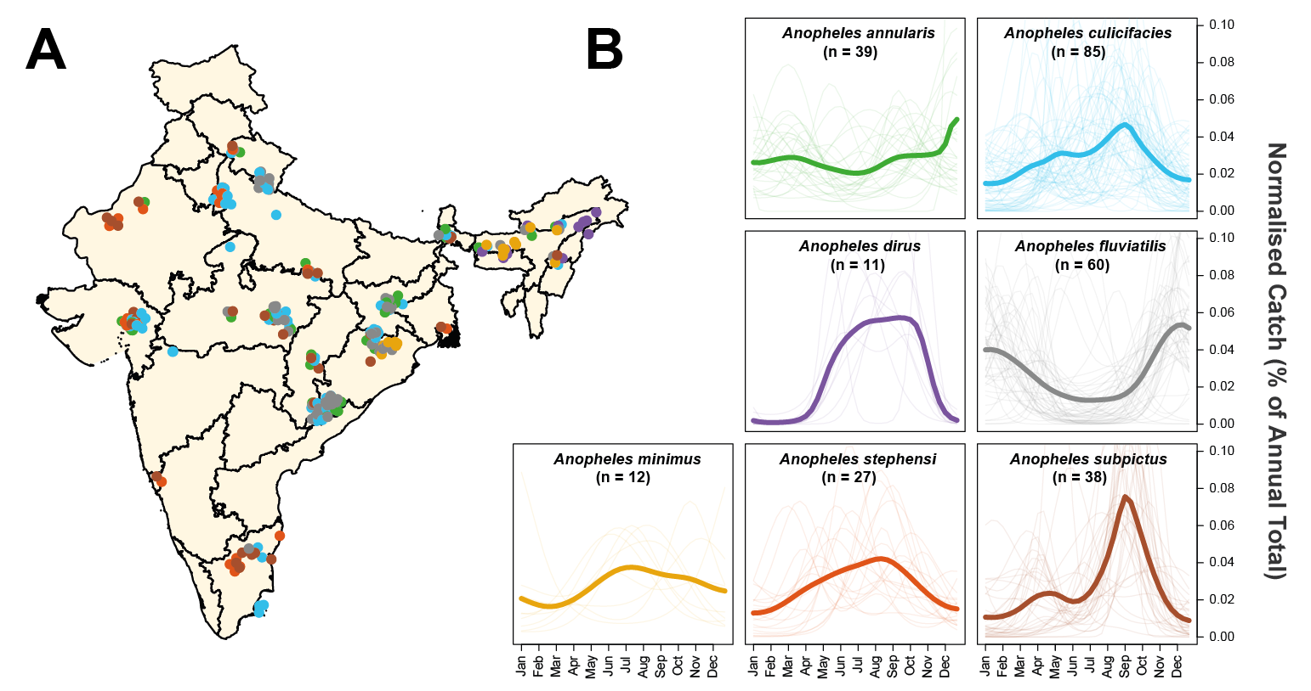

**Figure 1: Exploring and Mapping Species Specific Patterns of Mosquito Population Dynamics.** Negative Binomial Gaussian Processes incorporating a periodic kernel were fitted to each of the 272 time series collected from 118 locations across India collated as part of the systematic review. These fitted time series (representing monthly catches over the course of a year) were then normalised and the results plotted here, disaggregated by species. **(A)** Map of India showing the different locations for which time series data was available. Points represent a single collected time series, coloured according to species. **(B)** Normalised, Gaussian process fitted time series disaggregated by species. In all instances, pale lines represent a single time series for that particular species, and the brighter line is the mean of all of the time series belonging to that species, evaluated at that particular timepoint. Although a number of mosquito species show patterns of population dynamics with peaks around India’s monsoon season (typically June – September), there is substantial variation in the extent and nature of the observed dynamics, with many time series (and species) displaying different patterns.

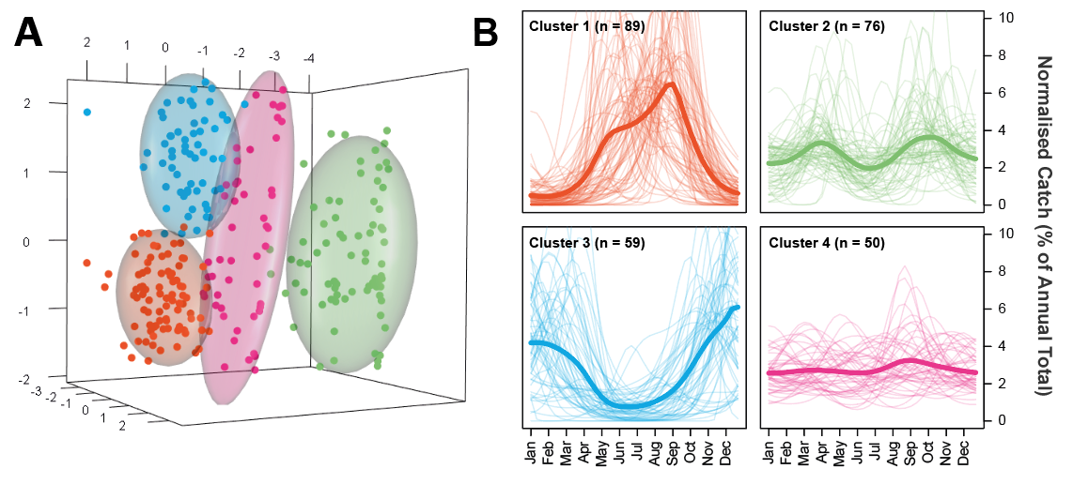

**Figure 2: Characterisation and Clustering of Time Series with Similar Temporal Properties.** A series of mathematical operations were applied to the fitted time series in order to characterise their temporal properties. A Principal Components Analysis was then carried out and the results clustered using the k-means algorithm. **(A)** Results of the k-means clustering algorithm for 4 clusters applied to a Principal Components Analysis. Colour of the points refers to cluster membership, coloured ellipsoids demarcate the 75th quantile of the density associated with each cluster. **(B)** Plots displaying the time series belonging to each cluster. Pale lines represent individual time series, brighter line represents the mean of all the time series belonging to that cluster, evaluated at each timepoint. Characterisation and clustering in this way revealed distinct groups of time series that share similar temporal properties.

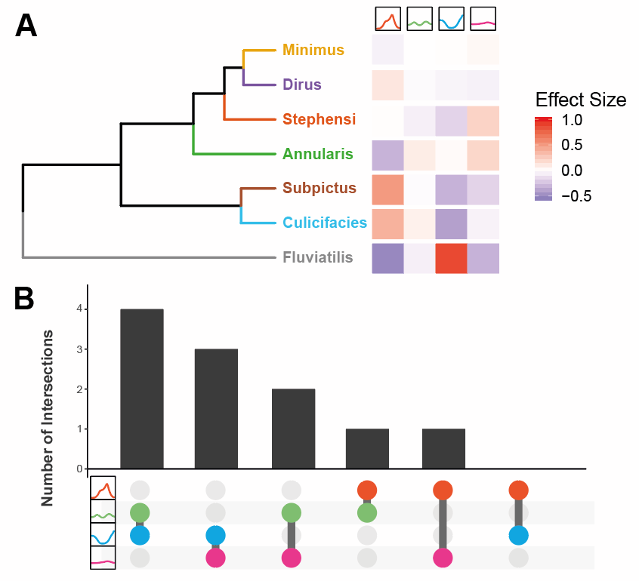

**Figure 3: Exploring the Role of Species-Specific Tendencies and Ecological Structure of Mosquito Temporal Dynamics.** Using both species and a suite of environmental variables as predictors, a multinomial logistic regression framework was used to drivers of mosquito population dynamics. This multinomial logistic regression was fitted within a Bayesian framework using the probabilistic programming language STAN. **(A)** Hierarchical clustering of the multinomial logistic regression results for species. Dendogram arranges mosquito species according to their relatedness as defined by the set of coefficient values for each species (1 for each cluster, displayed on the RHS and coloured according to the size of the coefficient). **(B)** Upset plot displaying the multinomial logistic regression results for the environmental covariates used as predictors. For each set of coefficients (1 for each cluster), the top 20 (out of a total of 66) were selected. These rankings were then compared across pairs of Clusters to assess the extent of overlap, which was minimal, supporting the idea of discrete ecological structuring across Clusters.

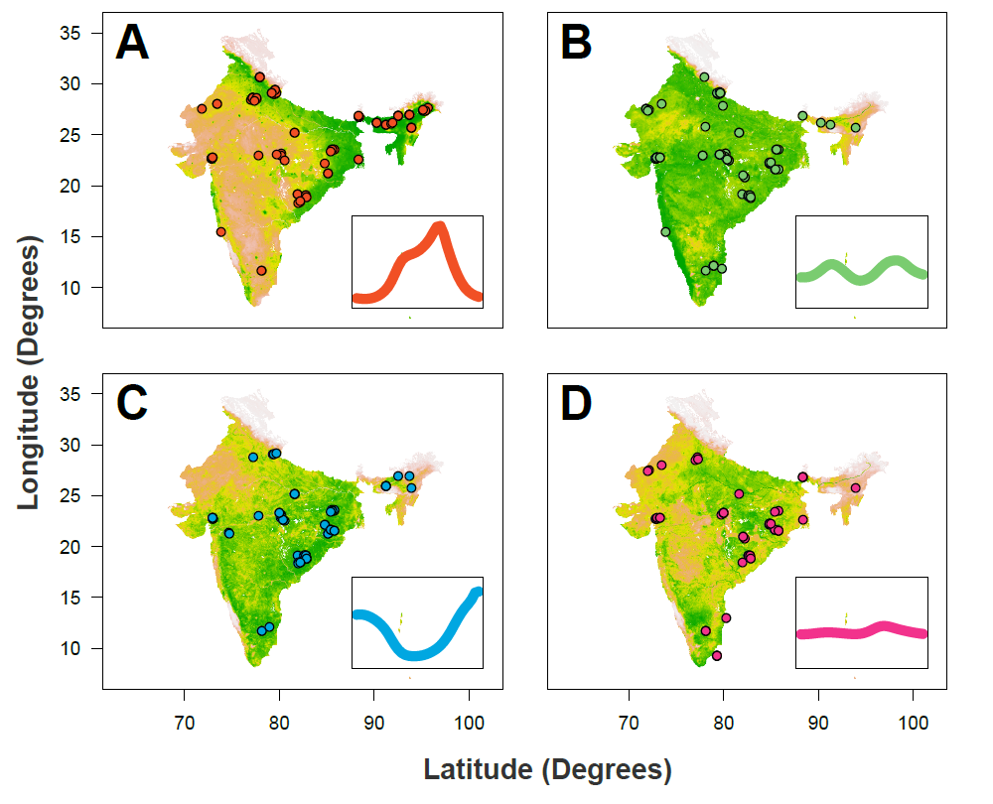

**Figure 4: Predictive Seasonality of Locations Across the Indian Subcontinent.** The results of the multinomial logistic regression were integrated with recently generated maps describing the probability of presence/absence for different *Anopheline* species. Together, these were used to generate estimates of a given area possessing at least one mosquito species with a particular temporal profile (as defined by the previously described clusters). **(A)** Results of this analysis for Cluster 1 (the “monsoon peak” cluster) – red dots describe the locations in which a mosquito species with a temporal profile assigned to Cluster 1 were found. **(B)** As for A, but for the “bimodal” cluster. **(C)** As for A, but for the “peak in dry season” cluster. **(D)** As for A, but for the “perennial” cluster.

**Discussion**

Understanding the temporal dynamics (including the start, duration and end) of malaria transmission in a given location represents a vital input to optimising control strategies aimed at reducing malaria transmission, enabling interventions to be deployed at times and in places where they can have the most impact. Despite this, many outstanding questions remain surrounding the drivers of these dynamics, particularly regarding their dependence on the underlying ecological structure of a setting. Here we leverage a collection of temporally disaggregated mosquito collected from across the Indian subcontinent in order to yield new insight into these dynamics and the comparative role of abiotic and biotic factors in shaping them. Our results reveal extensive diversity in mosquito population dynamics, with the extent of this diversity varying dramatically between species and across locations. We show that this diversity can be broadly grouped into a small number of clusters of time series possessing similar temporal patterns, and demonstrate clear ecological structuring of these different clusters, suggesting a role for the underlying ecological structure of an environment in determining and shaping mosquito population dynamics. Together, these results have enabled a clearer understanding of the comparative contributions of biotic (specific specific preferences) and abiotic (the broader ecological structure of the environment) in shaping mosquito population dynamics, and, by extension, the temporal profile of malaria risk.

Of particular interest to emerge from this work is the consistent pattern of peaking during the dry season observed for *Anopheles fluviatilis*. Whilst previous work has identified these dynamics28,29, our work highlights two important features: firstly that these dynamics are observed across high proportion of settings in which *Anopheles fluviatilis* is found (rather than being a chance finding in a single location), and secondly that these dynamics are largely restricted to *Anopheles fluviatilis*. This is consistent with recent work that has identified streams and surrounding stagnant water as the species’ preferred breeding site30; breeding sites that become inundated and unsuitable during the monsoon season but that becoming increasingly suitable as the dry season ensues. By contrast to *Anopheles fluviatilis*, whose temporal dynamics appeared to be relatively consistent irrespective of the ecological setting, we observed extensive plasticity in the variation and temporal dynamics of other mosquito species depending on the location. *Anopheles culicifacies*, a dominant vector thought to be responsible for the majority of malaria transmission in both central and (more recently) northeastern India31,32, was found to display a wide array of different dynamics, ranging from peaking during the monsoon season, to bimodal and even perennial behaviour depending on the sampling site. As with *Anopheles fluviatilis*, these results can likely be understood in the context of the species’ breeding habits. *Anopheles culicifacies* has been shown to be able to exploit a wide range of fresh water breeding habitats33,34, as well as brackish sources35. These contrasting results for *Anopheles culicifacies* and *Anopheles fluviatilis* highlight the complex interplay that sees species specific breeding preferences (or the lack thereof) interact with underlying ecological structure (that modulates breeding site availability and productivity) to determine the temporal dynamics of mosquito populations. Together, these results highlight important, species-specific differences in the plasticity of their population dynamics, and underscore the importance of integrating considerations of both species composition and ecological structure of the into understanding of malaria transmission.

In addition to these species-specific associations with particular temporal profiles, our work modelling membership of a particular cluster of temporal patterns revealed an important role of the environment in shaping mosquito population dynamics. Notably, it revealed important and cluster-specific associations with particular ecological variables, such as the role of ambient temperature and its fluctuations. Temperature is an important determinant of various mosquito traits relevant to malaria transmission – indeed, previous research has highlighted the intimate dependence on temperature of many traits ranging from rates of immature development19 through to biting and mortality rates20. In this context, of interest to emerge from our modelling results was that Isothermality (i.e. constant temperature) was positively associated with perennial population dynamics (belonging to Cluster 4), and a strong negative predictor of seasonal dynamics peaking in the monsoon season (Cluster 1). Similarly, temperature seasonality (measuring the extent of temperature fluctuation over the course of a year) was positively associated with seasonal dynamics and negatively associated with perennial dynamics. These results suggest that distinct ecological processes shape mosquito population dynamics to produce different temporal profiles, an idea further supported by examination of the cross-correlations for all the environmental predictors used in the model across clusters (**Supplementary Figure 8**). These results revealed extensive negative correlation between clusters, highlighings that each cluster, representing a distinct set of temporal patterns, are shaped by different, and often antagonistic ecological forces, supporting the notion of distinct ecological structuring of temporal dynamics. In conjunction with the results presented above, these findings suggest that mosquito population dynamics represent a complex interplay between biotic (species specific factors including but not limited to breeding site preferences) and abiotic (ecological factors including considerations of both the underlying hydrological environment as well as other factors such as the temperature profile) – and that comparative importance of these two sets of factors depends intimately on the particular species and setting. For some species (such as *Anopheles fluviatilis*), species specific factors dominate yielding dynamics that are similar across ecologically disparate locations. For others (such as *Anopheles culicifacies*), dynamics are far more plastic and subject to the underlying ecological structure of the environment, yielding the extensive diversity observed in dynamics across different locations observed for this species.

Whilst these analyses have yielded insight into the forces shaping mosquito population dynamics, it is important to note the relatively limited predictive performance of the model. There are likely several reasons for this, but important to note is that the environmental covariates used here for prediction were primarily developed to map and define static phenomena such as malaria prevalence36 and mosquito presence/absence25, rather than temporal processes (such as mosquito population dynamics). It is likely that different (although possibly overlapping) ecological features define the range and dynamics of mosquito populations, likely limiting the model’s predictive power. Additionally, our analyses were constrained by the incomplete and often ambiguous nature of location descriptions in papers. This precluded exact delineation of the sampling site in many instances, necessitating aggregation of covariate values up to large spatial scales– at these scales, potentially important features of the microenvironment such as smaller water sources and fine scale variation in ambient temperature (both known to be important factors regulating mosquito populations18,37–40) might be missed. Future work involving better spatial resolution of sampling sites and the principled development of novel environmental covariates better reflecting the ecological processes governing temporal dynamics would likely contribute to improved predictive performance.

Another important limitation of the work presented here is the absence of a link between the modelled mosquito temporal dynamics and the actual temporal profile of malaria risk. Whilst an association between these two quantities is well established, with their profiles typically highly correlated (e.g. 41,42), the nature and extent of this relationship, particularly how it varies across mosquito species, remains less clear. It can frequently be non-linear and vary with malaria endemicity43, mosquito abundance44 and vector competence45, amongst other factors. Our analyses were unable to explore many of these factors: due to the extensive heterogeneity in sampling methods used to catch the mosquitoes and the reported units, we were unable to systematically explore variation in mosquito abundance reported. Similarly, the lack of accompanying epidemiological information precludes us from beginning to better resolve the competence and comparative contributions of different mosquito species to malaria transmission: in doing so, this limits our ability to translate a given temporal pattern into metrics relevant to malaria transmission, such as the Entomological Inoculation Rate (EIR). There is thought to be substantial variation in the relevance of different mosquito species to malaria transmission, with this capacity to transmit determined by a complex interplay of vector-parasite compatibility. Indeed, there is evidence to suggest that *Anopheles culicifacies* contributes disproportionately to transmission across the Indian subcontinent34 (although recent research suggests that vectors previously considered “secondary” (e.g. *Anopheles subpictus*) might actually have a previously unappreciated role to play in sustaining malaria transmission, particularly in setting characterised by mosquito populations with discordant temporal dynamics46). Whilst we mitigate this limitation somewhat by focussing our analyses specifically on dominant vector species previously established as relevant to malaria transmission in India31, it is not necessarily the case then that each of the mosquito species analysed here are equally relevant to malaria transmission.

Overall however, and despite these limitations, our work yields new insight into the drivers of the temporal processes governing malaria transmission. We show that temporal variation in mosquito populations are driven by a complex interplay of biotic and abiotic factors; factors that together yield a wide diversity of different temporal patterns and dynamics. A better understanding of these ecological factors is vital, given that understanding these dynamics in a given location represents a vital and operationally relevant input to optimising control strategies (such as Seasonal Malaria Chemoprevention21,47 or Indoor Residual Spraying23,48). Although important further work remains to better resolve additional factors that along with population dynamics define the temporal profile of malaria risk (such as overall mosquito abundance and vector competence), the analyses presented here provides a framework facilitating the synthesis of entomological data and in doing so provides new insight into the diversity of dynamics these vectors display.

**References**

1. World Health Organization. WHO | World Malaria Report 2016. *WHO* (2017).

2. Phillips, M. A. *et al.* Malaria. *Nat. Rev. Dis. Prim.* **3**, 17050 (2017).

3. Warrell, D. A. & Gilles, H. M. *Essential Malariology*. (CRC Press, 2002).

4. Hay, S. I. *et al.* Developing Global Maps of the Dominant Anopheles Vectors of Human Malaria. *PLoS Med.* **7**, e1000209 (2010).

5. Sinka, M. E. Global Distribution of the Dominant Vector Species of Malaria. in *Anopheles mosquitoes - New insights into malaria vectors* (InTech, 2013). doi:10.5772/54163

6. Sinka, M. E. *et al.* A global map of dominant malaria vectors. *Parasit. Vectors* **5**, 69 (2012).

7. Kraemer, M. U. G. *et al.* Past and future spread of the arbovirus vectors Aedes aegypti and Aedes albopictus. *Nat. Microbiol.* **4**, 854–863 (2019).

8. Gimnig, J. E., Ombok, M., Kamau, L. & Hawley, W. A. Characteristics of larval anopheline (Diptera: Culicidae) habitats in Western Kenya. *J. Med. Entomol.* **38**, 282–8 (2001).

9. Cairns, M. *et al.* Estimating the potential public health impact of seasonal malaria chemoprevention in African children. *Nat. Commun.* **3**, 881 (2012).

10. White, M. T. *et al.* Modelling the impact of vector control interventions on Anopheles gambiae population dynamics. *Parasit. Vectors* **4**, 153 (2011).

11. Sinka, M. E. *et al.* The dominant Anopheles vectors of human malaria in Africa, Europe and the Middle East: occurrence data, distribution maps and bionomic précis. *Parasit. Vectors* **3**, 117 (2010).

12. Kaindoa, E. W. *et al.* Interventions that effectively target Anopheles funestus mosquitoes could significantly improve control of persistent malaria transmission in south-eastern Tanzania. *PLoS One* **12**, (2017).

13. Kelly-Hope, L. A., Hemingway, J. & McKenzie, F. E. Environmental factors associated with the malaria vectors Anopheles gambiae and Anopheles funestus in Kenya. *Malar. J.* **8**, 268 (2009).

14. Singh, R. K., Haq, S., Kumar, G. & Dhiman, R. C. U Bionomics and vectorial capacity of Anopheles annularis with special reference to India: a review. *J. Commun. Dis.* **45**, 1–16 (2013).

15. Fillinger, U., Sonye, G., Killeen, G. F., Knols, B. G. J. & Becker, N. The practical importance of permanent and semipermanent habitats for controlling aquatic stages of Anopheles gambiae sensu lato mosquitoes: operational observations from a rural town in western Kenya. *Trop. Med. Int. Heal.* **9**, 1274–1289 (2004).

16. Koenraadt, C. J. ., Githeko, A. . & Takken, W. The effects of rainfall and evapotranspiration on the temporal dynamics of Anopheles gambiae s.s. and Anopheles arabiensis in a Kenyan village. *Acta Trop.* **90**, 141–153 (2004).

17. Paaijmans, K. P., Wandago, M. O., Githeko, A. K. & Takken, W. Unexpected High Losses of Anopheles gambiae Larvae Due to Rainfall. *PLoS One* **2**, e1146 (2007).

18. Majambere, S., Fillinger, U., Sayer, D. R., Green, C. & Lindsay, S. W. Spatial distribution of mosquito larvae and the potential for targeted larval control in The Gambia. *Am. J. Trop. Med. Hyg.* **79**, 19–27 (2008).

19. Bayoh, M. N. & Lindsay, S. W. Effect of temperature on the development of the aquatic stages of Anopheles gambiae sensu stricto (Diptera: Culicidae) . *Bull. Entomol. Res.* **93**, 375–381 (2003).

20. Shapiro, L. L. M., Whitehead, S. A. & Thomas, M. B. Quantifying the effects of temperature on mosquito and parasite traits that determine the transmission potential of human malaria. *PLOS Biol.* **15**, e2003489 (2017).

21. Wilson, A. L. & IPTc Taskforce. A Systematic Review and Meta-Analysis of the Efficacy and Safety of Intermittent Preventive Treatment of Malaria in Children (IPTc). *PLoS One* **6**, e16976 (2011).

22. Pluess, B., Tanser, F. C., Lengeler, C. & Sharp, B. L. Indoor residual spraying for preventing malaria. *Cochrane Database Syst. Rev.* (2010). doi:10.1002/14651858.CD006657.pub2

23. Health Organization, W. *AN OPERATIONAL MANUAL FOR INDOOR RESIDUAL SPRAYING (IRS) FOR MALARIA TRANSMISSION CONTROL AND ELIMINATION SECOND EDITION INDOOR RESIDUAL SPRAYING*.

24. Ross, A., Maire, N., Sicuri, E., Smith, T. & Conteh, L. Determinants of the cost-effectiveness of intermittent preventive treatment for malaria in infants and children. *PLoS One* **6**, (2011).

25. Sinka, M. E. *et al.* The dominant Anopheles vectors of human malaria in the Asia-Pacific region: occurrence data, distribution maps and bionomic précis. *Parasit. Vectors* **4**, 89 (2011).

26. Carpenter, B. *et al.* Stan: A Probabilistic Programming Language. *J. Stat. Softw.* **76**, (2017).

27. Fick, S. E. & Hijmans, R. J. WorldClim 2: new 1-km spatial resolution climate surfaces for global land areas. *Int. J. Climatol.* **37**, 4302–4315 (2017).

28. Sahu, S. S. *et al.* Bionomics of Anopheles fluviatilis and Anopheles culicifacies (Diptera: Culicidae) in Relation to Malaria Transmission in East-Central India. *J. Med. Entomol.* **54**, 821–830 (2017).

29. Gunasekaran, K., Jambulingam, P., Sadanandane, C., Sahu, S. S. & Das, P. K. D Reliability of light trap sampling for Anopheles fluviatilis, a vector of malaria. *Acta Trop.* **58**, 1–11 (1994).

30. Dash, S. *et al.* Preferential breeding habitats of sibling species complexes of Anopheles fluviatilis in east-central India. *~ 91 ~ Int. J. Mosq. Res.* **5**, 91–95 (2018).

31. Dev, V. & Sharma, V. P. The Dominant Mosquito Vectors of Human Malaria in India. in *Anopheles mosquitoes - New insights into malaria vectors* (InTech, 2013). doi:10.5772/55215

32. Akhtar, N., Nagpal, B. N., Kapoor, N., Srivastava, A. & Valecha, N. Role of an. Culicifacies as a vector of malaria in changing ecological scenario of northeastern states of India. *J. Vector Borne Dis.* **53**, 264–271 (2016).

33. Surendran, S. N. & Ramasamy, R. Some characteristics of the larval breeding sites of Anopheles culicifacies species B and E in Sri Lanka. *J. Vector Borne Dis.* **42**, 39–44 (2005).

34. Barik, T. K., Sahu, B. & Swain, V. A review on Anopheles culicifacies: From bionomics to control with special reference to Indian subcontinent. *Acta Tropica* **109**, 87–97 (2009).

35. Jude, P. J., Dharshini, S., Vinobaba, M., Surendran, S. N. & Ramasamy, R. Anopheles culicifacies breeding in brackish waters in Sri Lanka and implications for malaria control. *Malar. J.* **9**, (2010).

36. Bhatt, S. *et al.* The effect of malaria control on Plasmodium falciparum in Africa between 2000 and 2015. *Nature* **526**, 207–211 (2015).

37. Gimnig, J. E., Ombok, M., Kamau, L. & Hawley, W. A. Characteristics of Larval Anopheline (Diptera: Culicidae) Habitats in Western Kenya. *J. Med. Entomol.* **38**, 282–288 (2001).

38. Mattah, P. A. D. *et al.* Diversity in breeding sites and distribution of Anopheles mosquitoes in selected urban areas of southern Ghana. *Parasit. Vectors* **10**, 25 (2017).

39. Thomas, S. *et al.* Microclimate variables of the ambient environment deliver the actual estimates of the extrinsic incubation period of Plasmodium vivax and Plasmodium falciparum: A study from a malaria-endemic urban setting, Chennai in India. *Malar. J.* **17**, (2018).

40. Paaijmans, K. P. & Thomas, M. B. The influence of mosquito resting behaviour and associated microclimate for malaria risk. *Malaria Journal* **10**, (2011).

41. Bashar, K. & Tuno, N. Seasonal abundance of Anopheles mosquitoes and their association with meteorological factors and malaria incidence in Bangladesh. *Parasit. Vectors* **7**, 442 (2014).

42. GALARDO, A. K. R. *et al.* Seasonal abundance of anopheline mosquitoes and their association with rainfall and malaria along the Matapí River, Amapí, Brazil. *Med. Vet. Entomol.* **23**, 335–349 (2009).

43. Churcher, T. S., Trape, J. F. & Cohuet, A. Human-to-mosquito transmission efficiency increases as malaria is controlled. *Nat. Commun.* **6**, (2015).

44. Romeo-Aznar, V., Paul, R., Telle, O. & Pascual, M. Mosquito-borne transmission in urban landscapes: The missing link between vector abundance and human density. *Proc. R. Soc. B Biol. Sci.* **285**, (2018).

45. Beck-Johnson, L. M. *et al.* The importance of temperature fluctuations in understanding mosquito population dynamics and malaria risk. *R. Soc. Open Sci.* **4**, (2017).

46. Kumar, A. *et al.* Anopheles subpictus carry human malaria parasites in an urban area of Western India and may facilitate perennial malaria transmission. *Malar. J.* **15**, (2016).

47. Meremikwu, M. M., Donegan, S., Sinclair, D., Esu, E. & Oringanje, C. Intermittent preventive treatment for malaria in children living in areas with seasonal transmission. *Cochrane Database Syst. Rev.* (2012). doi:10.1002/14651858.cd003756.pub4

48. Worrall, E., Connor, S. J. & Thomson, M. C. A model to simulate the impact of timing, coverage and transmission intensity on the effectiveness of indoor residual spraying (IRS) for malaria control. *Trop. Med. Int. Heal.* **12**, 75–88 (2006).